



Name: Paarth Singh
Class: XI
Section: S1
Submitted To: Ms. Sandhya Ma’am
CERTIFICATE

This is to certify that Paarth Singh of class XI S1, Roll No 22 has completed CS Practical File under my supervision and guidance as per the latest curriculum of Central Board of Secondary Education (2021-2022).

Ms. Sandhya Ma’am
Teacher In-charge Institution Rubber Stamp

Date:-08\10\2021
ACKNOWLEDGEMENT

In the accomplishment of this practical file successfully, many people have best owned upon me their blessings and the heart pledged support, this time I am utilizing to thank all the people who have been concerned with this practical file. Primarily I would thank God for being able to complete this project with success. Then I would like to thank my Principal Mr. Gaurav Bedi and Computer Science teacher Ms. Sandhya Singh, whose valuable guidance has been the ones that helped me prepare this file and make it a success. Their suggestions and instructions have served as the major contributor towards the completion of the file. Then I would like to thank my parents and friends who have helped me with their valuable suggestions and guidance has been very helpful in various phases. Last but not the least I would like to thank my classmates who have helped me a lot.

Name: Paarth Singh
Roll.No:23
INDEX
1) Write a program to show entered string is a palindrome or not.
2) Write a program to show statistics of characters in the given line (to counts the number of alphabets, digits, uppercase, lowercase, spaces and other characters).
3) WAP to remove all odd numbers from the given list.
4) write a program to display those string which are starting with ‘A’ from the given list.
5) Write a program to find and display the sum of all the values which are ending with 3 from a list.
6) Write a program to swap the content with next value, if it is divisible by 7 in a list.
7) Write a program to accept values from a user and create a tuple.
8) Write a program to input total number of sections and stream name in 11th class and display all information on the output screen.
9) Write a program to find factorial of entered number.
10) Write a program to call func () to find greater out of entered two numbers.
11) Write a program to show all non -prime numbers in the entered range.
12) Write a program to insert item on selected position in list and print the updated list.
13) Write a program to read a string and print it after replacing each of its capital alphabets by the corresponding small alphabet and each small alphabet by its corresponding capital alphabet.
14) Write a program Get1from2 () function transfer the content from two Lists First [ ] and Second [ ] to list All [ ] and display contents to user. Both lists to be inputted as parameters in the function.

PROGRAMS
Q.1) Write a program to show entered string is a palindrome or not.
A.1)
SOURCE CODE:- 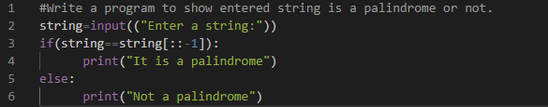

OUTPUT:-
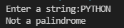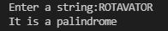

Q.2) Write a program to show statistics of characters in the given line (to counts the number of alphabets, digits, uppercase, lowercase, spaces and other characters).
A.2)
SOURCECODE:- 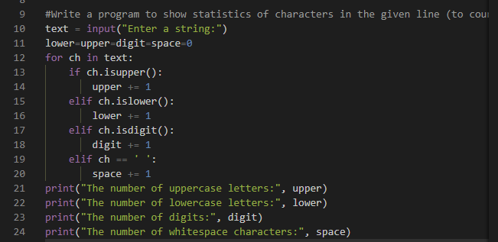

OUTPUT:-
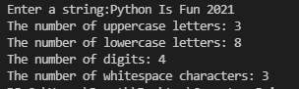

Q.3) Write a program to remove all odd numbers from the given list.
A.3)
SOURCECODE:-
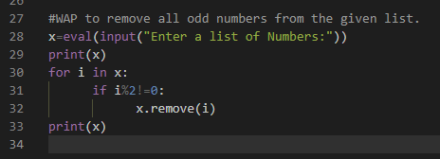

OUTPUT:-
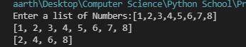

Q.4) write a program to display those string which are starting with ‘A’ from the given list.
A.4)
SOURCECODE:-
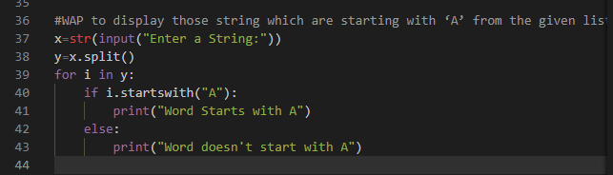

OUTPUT:-
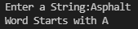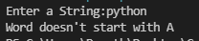

Q.5) Write a program to find and display the sum of all the values which are ending with 3 from a list.
A.5)
SOURCECODE:-
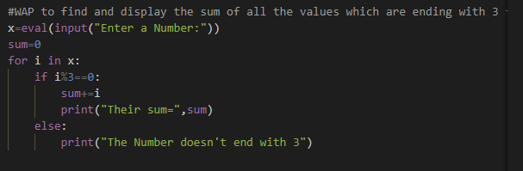

OUTPUT:-
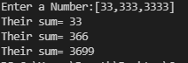

Q.6) Write a program to swap the content with next value, if it is divisible by 7 in a list.
A.6)
SOURCECODE:-
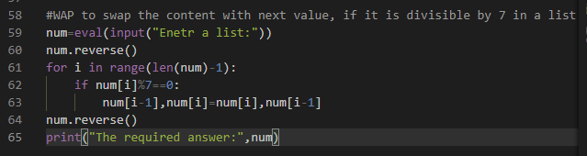
OUTPUT:-
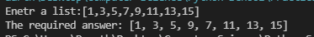
Q.7) Write a program to accept values from a user and create a tuple.
A.7)
SOURCECODE:-
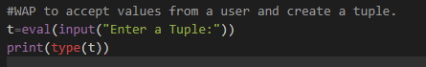
OUTPUT:-
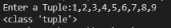

Q.8) Write a program to input total number of sections and stream name in 11th class and display all information on the output screen.
A.8)
SOURCECODE:-
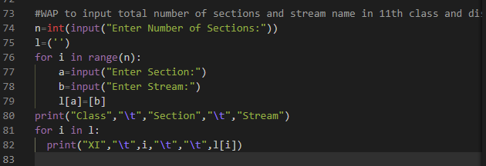

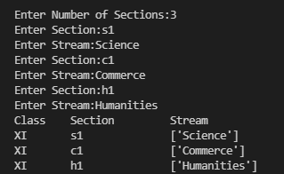
OUTPUT:-

Q.9) Write a program to find factorial of entered number.
A.9)
SOURCECODE:-
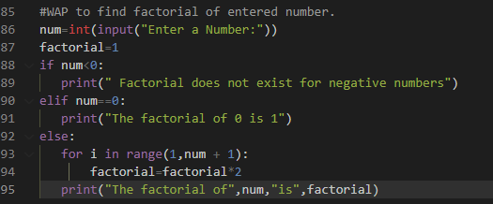

OUTPUT:-
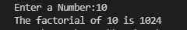

Q.10) Write a program to call func () to find greater out of entered two numbers.
A.10)
SOURCECODE:-
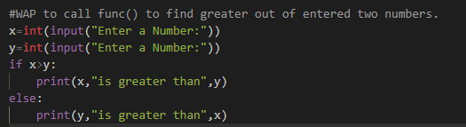

OUTPUT:-
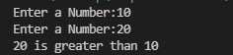

Q.11) Write a program to show all prime numbers in the entered range.
A.11)
SOURCECODE:-
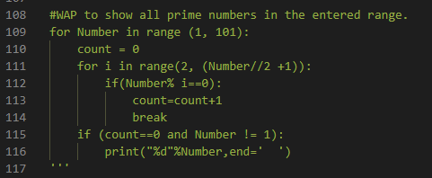

OUTPUT:-

Q.12). Write a program to insert item on selected position in list and print the updated list.
A.12)
SOURCECODE:-
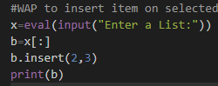
OUTPUT:-
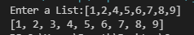

Q.13) Write a program to read a string and print it after replacing each of its capital alphabets by the corresponding small alphabet and each small alphabet by its corresponding capital alphabet.
A.13)
SOURCE CODE:-
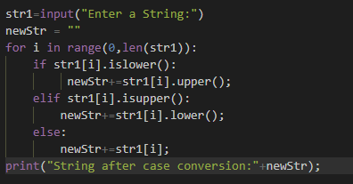

OUTPUT:-
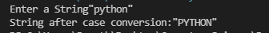

Q.14) Write a program Get1from2 () function transfer the content from two Lists First [ ] and Second [ ] to list All [ ] and display contents to user. Both lists to be inputted as parameters in the function.
A.14)
SOURCE CODE:-
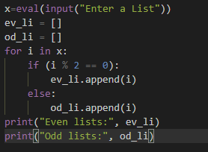

OUTPUT:-
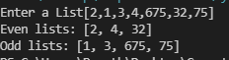

TERM-2
Questions:-
1) WAP that find an elements index/position in a tuple. Without using index ().
2) WAP that checks for presence of a value inside a dictionary and prints its keys with ignore case.
3) Write a Menu driven program to calculate: (a) Area of the circle, (b) Area of the square, (c) Area of rectangle.
4) WAP to create a dictionary named years whose keys are month’s names and values are corresponding number of days.
5) WAP that repeatedly asks the user to enter product name and prices. Store all of them in a dictionary whose keys are product names and values are prices. Also write a code to search an item form a dictionary.
6) WAP to create a tuple storing 9 terms of the Fibonacci series.
7) WAP as per following regulations:
(a) Return the length of the shortest string in the tuple of a strings.
(b)PRECONDITION:-the tuple contains at least one element.
8)Write a function check(key) which takes a key as argument and check weather that key is present in dictionary or not.
9) WAP to accept the number of terms say n form the user and display the dictionary in the form of {n: n*5}
10) WAP to display maximum and the minimum value in a dictionary.

PROGRAMS
Q.1> WAP that find an elements index/position in a tuple. Without using index ().
A.1>
Source Code:-
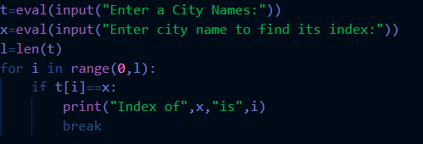
Output:-
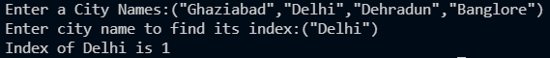

Q.2> WAP that checks for presence of a value inside a dictionary and prints its keys with ignore case.
A.2>
Source Code:-
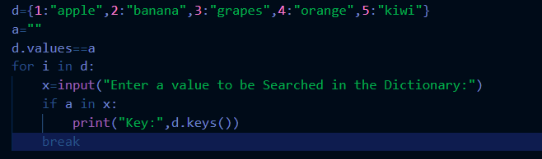

Output:-

Q.3> Write a Menu driven program to calculate: (a) Area of the circle, (b) Area of the square, (c) Area of rectangle
A.3>
Source Code:-
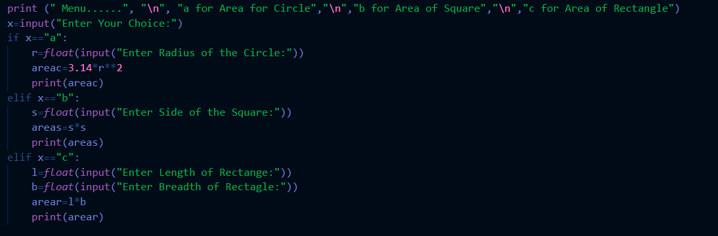

Output:-
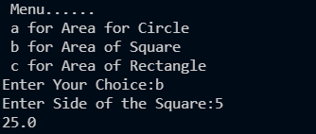

Q.4> WAP to create a dictionary named years whose keys are month’s names and values are corresponding number of days.
A.4>
Source Code:-
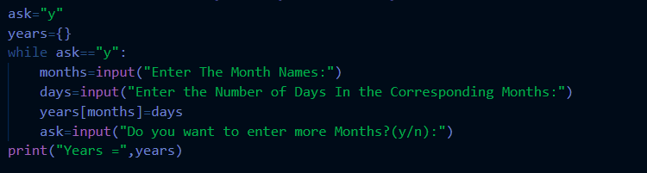

Output:-
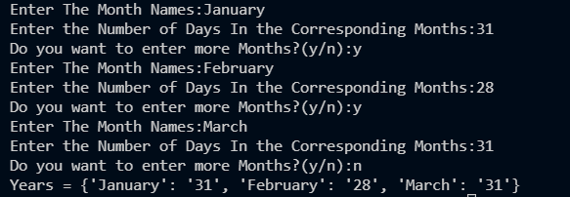

Q.5> WAP that repeatedly asks the user to enter product name and prices. Store all of them in a dictionary whose keys are product names and values are prices. Also write a code to search an item form a dictionary.
A.5>
Source Code:-
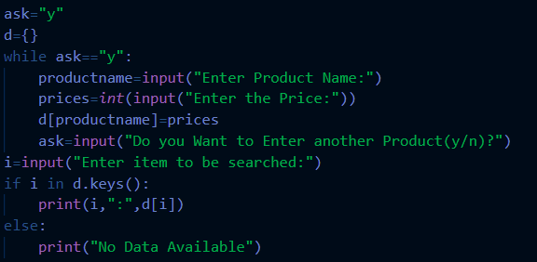

Output:-
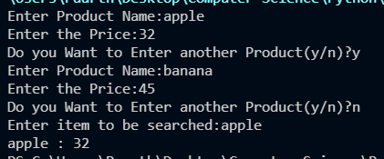

Q.6> WAP to create a tuple storing 9 terms of the Fibonacci series
A.6>
Source Code:-
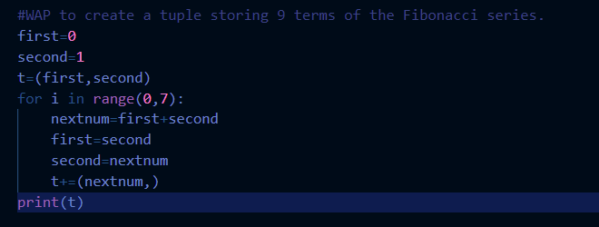

Output:-

Q.7> WAP as per following regulations:
(a) Return the length of the shortest string in the tuple of a strings.
(b)PRECONDITION:-the tuple contains at least one element.
A.7>
Source code:-
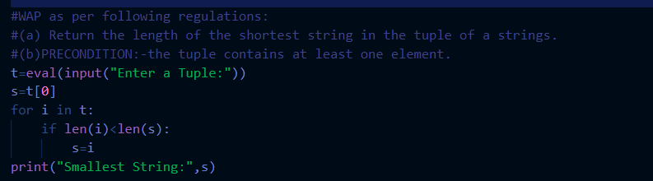

Output:-

Q.8> Write a function check(key) which takes a key as argument and check weather that key is present in dictionary or not.
A.8>
Source Code:- 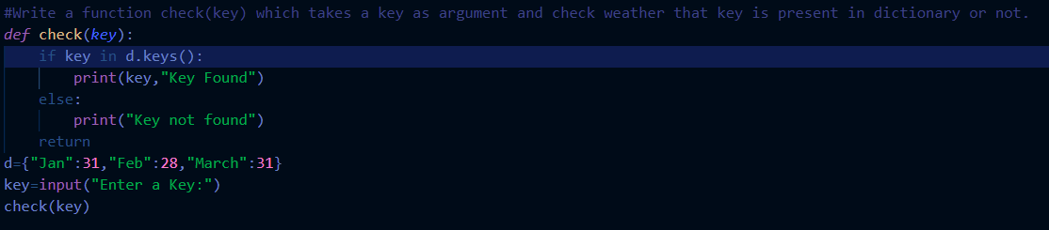

Output:-
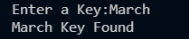

Q.9> WAP to accept the number of terms say n form the user and display the dictionary in the form of {n: n*5}
A.9>
Source Code:-
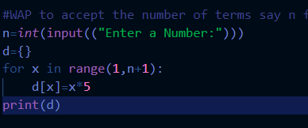

Output:-
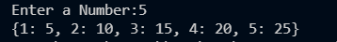

Q.10> WAP to display maximum and the minimum value in a dictionary.
A.10>
Source Code:-
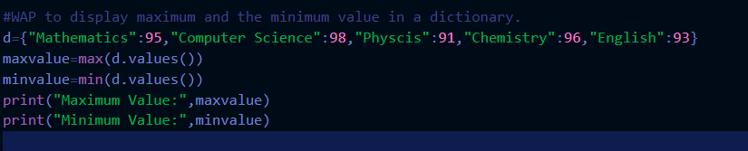
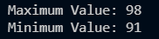
Output:-

